SATISH CHANDRA MEMORIAL SCHOOL
CLASS -IX
HOTS
SUBJECT-SCIENCE
1. Observe the following set up and answer the following:
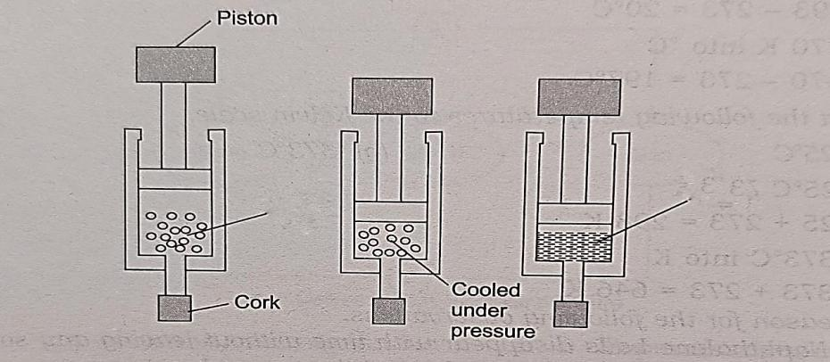
Y
X
A) X: Vapour Y: Liquid. B) X: Liquid Y: Liquid. C) X: Gas Y: Liquid. D) X: Liquid Y: Solid
2. The image given below shows data about the different types of matter.
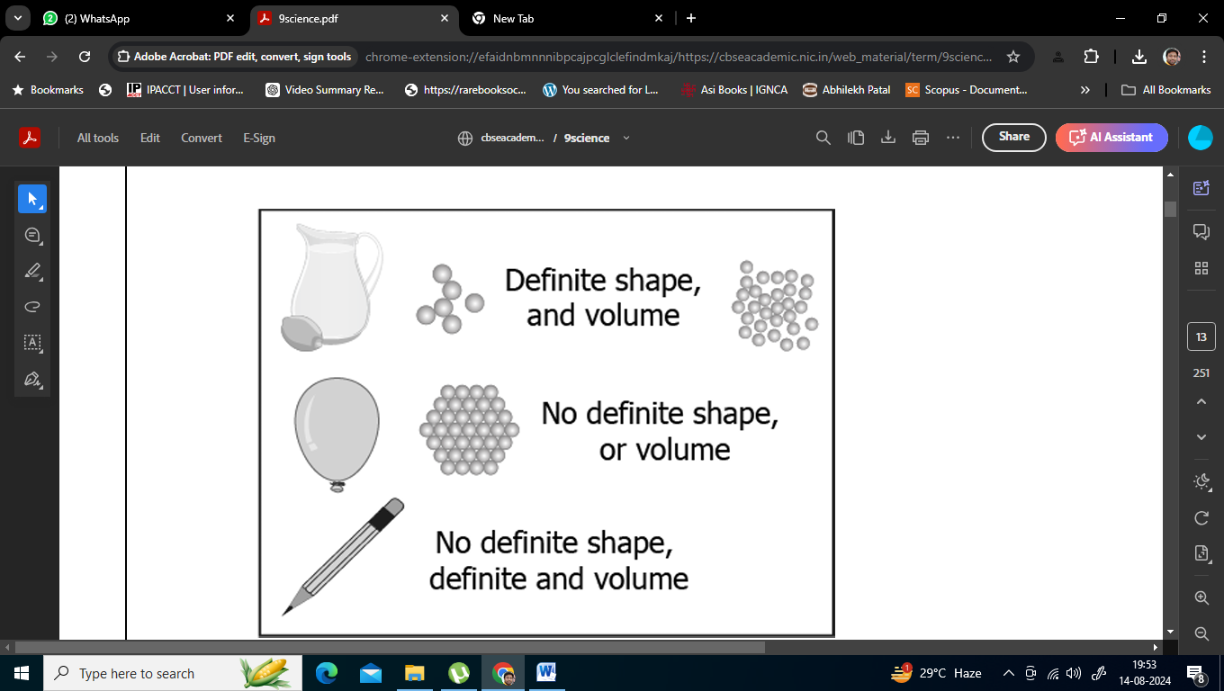
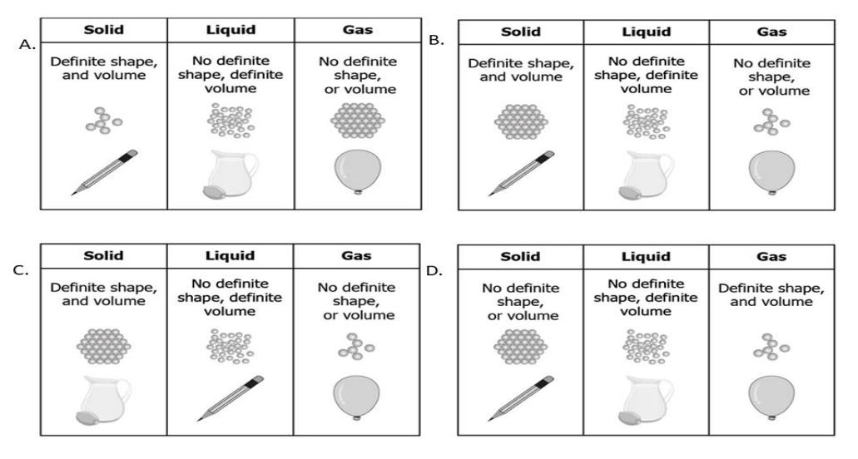
3. A student has a glass of hot water which is covered with a plate. The student wants to transfer the hot water into another glass. The student notices that as he lifts the plate, some air flows upwards as he carefully pours water. The student makes particle diagrams of steam, water and gas. Which diagram correctly shows the particle arrangement?
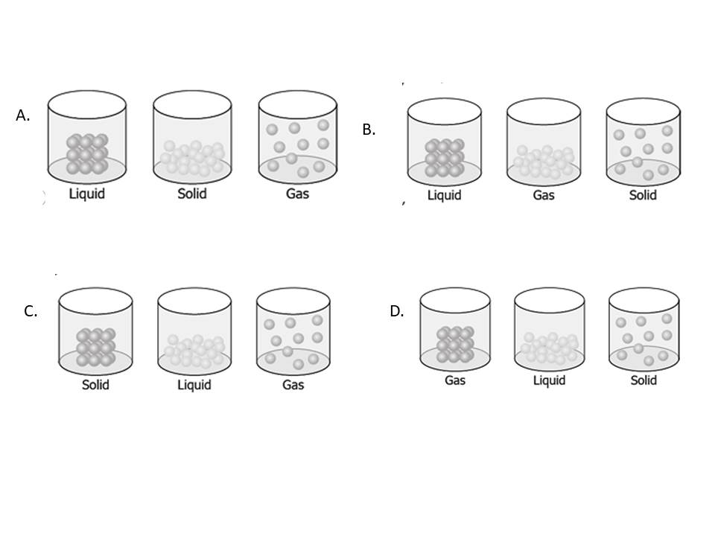
4. The arrangement of particles of an unknown substance at the same pressure at two different temperatures is shown in the diagrams:
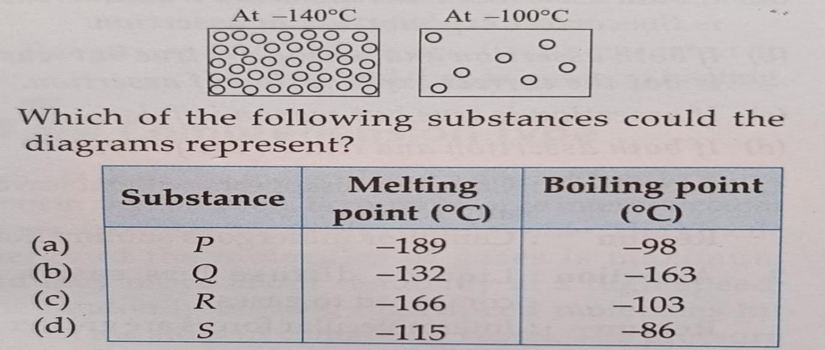
5. Assertion: Camphor disappears without leaving any residue.Reason: Camphor undergoes sublimation
A. If both Assertion and Reason are true and Reason is the correct explanation of Assertion . B. If both Assertion and Reason are true but Reason is not the correct explanation of Assertion.
C. If Assertion is true but Reason is false.
D. If Assertion is false, but Reason is true.
6. A 5 kg block is placed on a horizontal surface. A horizontal force of 20 N is applied to the block, causing it to accelerate. If the coefficient of kinetic friction between the block and the surface is 0.3, what is the acceleration of the block? (Assume g = 10 m/s^2). A) 2 m/s². . B) 3 m/s² C) 4 m/s². . D) 5 m/s²
7. A car of mass 1200 kg is moving on a straight road with a speed of 25 m/s. If the driver applies the brake and the car comes to rest in 8 seconds, what is the average retardation (deceleration) of the car? A) 2.5 m/s². B) 3.1 m/s² C) 3.5 m/s² D) 4.2 m/s²
8. A force of 10 N acts on an object of mass 2 kg for 2 seconds. If the object is initially at rest, what will be its velocity after 2 seconds? If the same force is applied for 4 seconds, what will be the velocity of the object? (Assume no friction).
A) 5 m/s, 10 m/s. B) 10 m/s, 20 m/s. C) 10 m/s, 15 m/s. D) 15 m/s, 30 m/s
9. A planet has a mass of 8 x 10^24 kg and a radius of 12000 km. What is the acceleration due to gravity on the surface of the planet? (Assume G = 6.67 x 10^-11 Nm²/kg²)
A) 5 m/s². B) 8 m/s². C) 10 m/s². D) 12 m/s²
10.An object is thrown upwards from the surface of the Earth with an initial velocity of 20 m/s. If the acceleration due to gravity is 10 m/s^2, what is the maximum height reached by the object? If the same object is thrown upwards from the surface of a planet with twice the mass and radius of the Earth, what will be the maximum height reached? (Assume no air resistance)
A) 20 m, 10 m B) 20 m, 20 m. C) 40 m, 20 m. D) 40 m, 40 m.
11.Two planets, X and Y, have masses in the ratio 2:3 and radii in the ratio 3:4. What is the ratio of their surface gravitational accelerations?
A) 4:3 B) 3:4 C) 8:9 D) 9:8
12. Guard cells: Transpiration ::Companion cells: _____________?
a) Photosynthesis b) Respiration d) Water absorption d) Food Transportation
13. The peripheral boundary of the vascular bundle is circumcircled with -
a) Cortex b) Pith c) Epidermis d) Pericycle
14. The aerenchyma tissue in water hyacinth plants are specialised for-
a) Photosynthesis c) Absorption of water
b) Providing buoyancy d) Transpiration
15. The first breakdown of glucose takes place in -
a) Nucleus b) Mitochondria c) Golgi bodies d) Ribosomes
16. The turgid condition of a cell results due to -
a) Endosmosis b) Exosmosis c) Diffusion d) Cell division

